1. We are testing the mangodb by using the simple_insert.js test cases on 1,2 and 4 threads; no multi-db and using the basic mongo shell:  
   python benchrun.py -f testcases/simple_insert.js -t 1 2 4

1. run only a simple test case Queries.Empty on 1, 2, and 4 thread:

command: python benchrun.py -f testcases/* --includeFilter Queries.Empty -t 1 2 4

For the second test, we tried Apache web server performance. The instances we test are the type T2.micro instance that we used for most of the modules and T4g.small. I tried with command: ab -c 10 -n 100 <http://172.31.87.34/modeltest1.html> and ab -c 100 -n 10000 <http://172.31.87.34/modeltest1.html> which means run 10000 requests by 100 concurrent users. And the results are shown in the figures and screen shot. The modeltest.html is a file that loads a small picture (screen shot). The first result are The running times are ranged from 1 to 10000 and wait time is in millisecond.

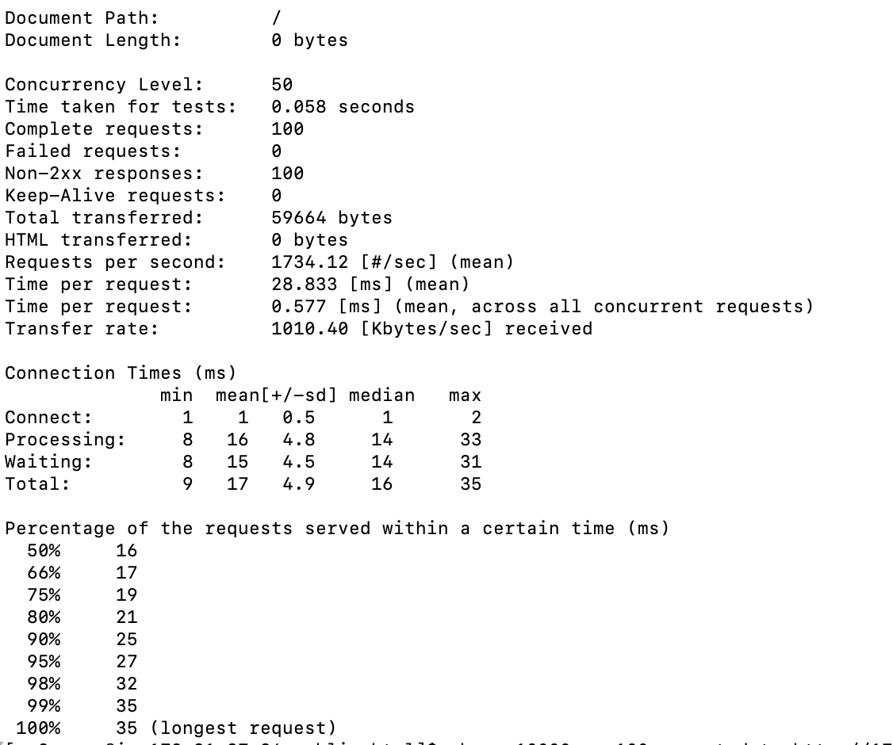

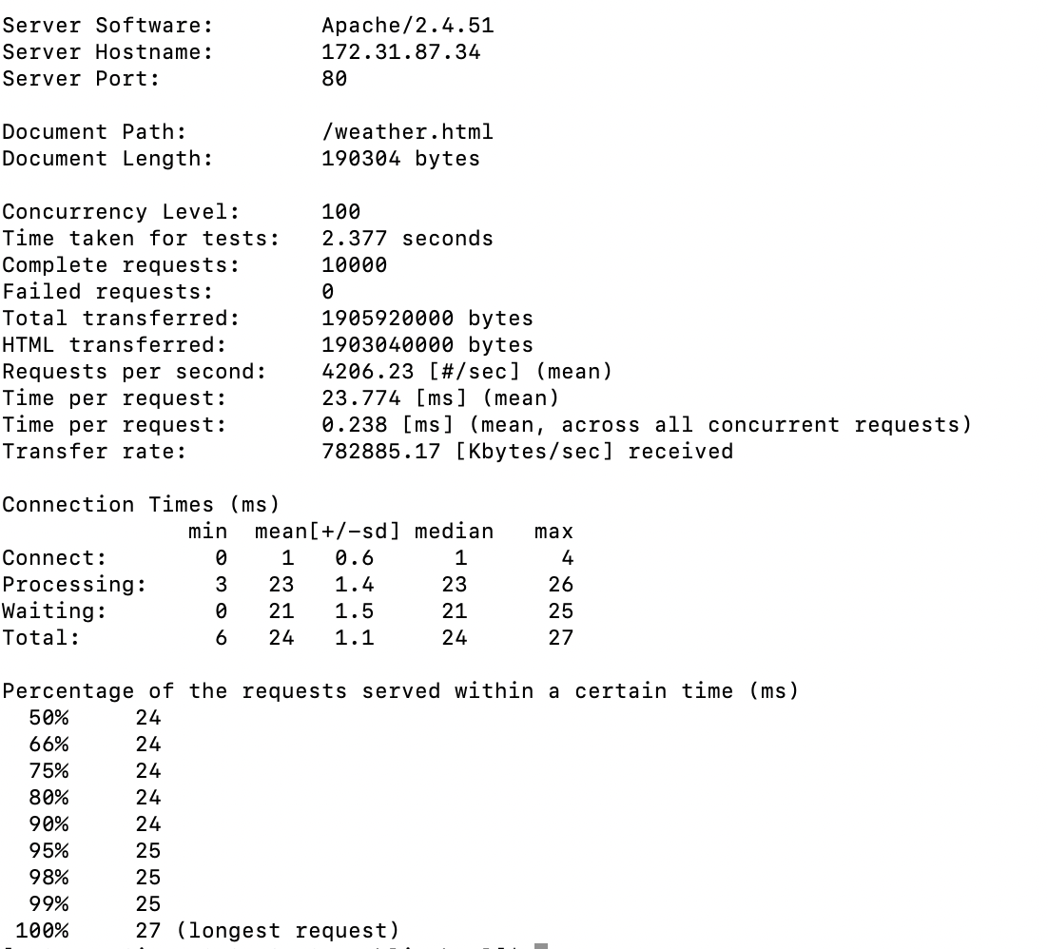

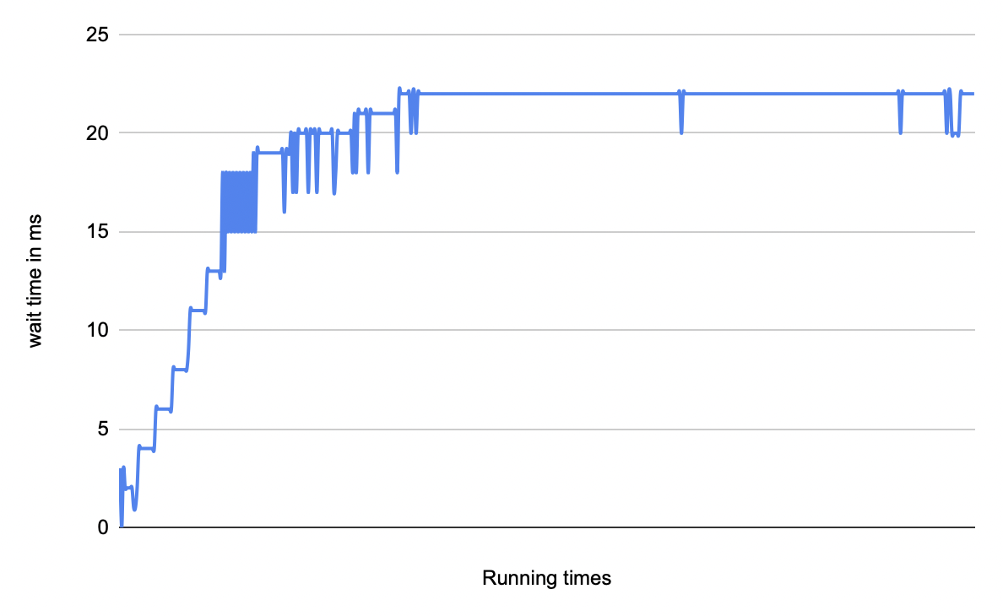

The running time is increasing considerably. For the t2.micro, the connection made is 1700 requests per second and the t4g.small can have 4200 requests per seconds. From my perspective, the main performance difference is caused by the vCPU and memory. The t2.micro only can have 1 vCPU but t4g.small can have 2 vCPU and 2GB of memory.

The bottleneck of the method is the instance type. If we can run with a large vCPU and memory instance, we can have more than 10000 requests per second. Since we dont need to deal with the database storage, the SSD option is not that important to us.

The instance and configuration will be t4.xlarge instance with 8 cores of vCPU and 32 GB of memory.